Richardson Extrapolation on the Validated Average GFMI

Objective
The objective of this investigation was to determine whether Richardson extrapolation can improve the accuracy of dq admittance identification from EMT simulations while reducing the computational cost compared with directly running a very fine PSCAD solver timestep.
The investigation examined whether a fixed Richardson order is suitable across different perturbation frequencies, or whether a multi-level formulation that accounts for more than one timestep-error term provides better results.
Three extrapolation approaches were tested. P=1 Richardson, P=2 Richardson and mixed h+h² Richardson at perturbation frequencies of 1, 5, and 10Hz.
The final results were validated against an independent 2 µs PSCAD reference. Robustness was assessed at two active-power operating points: OP1 with $P_{ref}=1.0$pu and OP2 with $P_{ref}=0.6$pu. Then compared against the inverter-side admittance obtained using the conventional Rezonance impedance-scan workflow.
This directly addresses the Student A project objective of evaluating whether Richardson post-processing can provide faster and/or more accurate impedance/admittance estimates than conventional scans.

Validated Average GFMI Model
A validated average GFMI model supplied by Student C was used for this investigation.
The use of this model was important because its conventional Rezonance impedance scan had already been reproduced successfully, providing a common model for comparison between Rezonance and external Richardson identification.
The model represents the grid-forming inverter using an average converter representation rather than explicit semiconductor switching.
Because the model does not contain PWM switching ripple, Richardson extrapolation can be applied directly to the recorded voltage and current waveforms without requiring the additional ripple-removal and envelope-extraction stages needed for a switching model.

Simulation Parameters
Parameter | Value
Model | Validated Student C average GFMI
Base apparent power | 2 MVA
Base line-line voltage | 0.69 kV
Fundamental frequency | 50 Hz
Perturbation frequencies | 1 Hz, 5 Hz, 10 Hz
d-axis perturbation | Voltage-magnitude perturbation
d-axis amplitude | 0.01 pu
q-axis perturbation | Phase-angle perturbation
q-axis amplitude | 0.5°
Coarse solver timestep | 50 µs
Fine solver timestep | 25 µs
Third timestep | 12.5 µs
Held-out reference timestep | 2 µs
Channel logging timestep | 50 µs for all simulations
Simulation duration | 10 s
Analysis window | 3–10 s
dq-angle fitting window | 0.5–1.9 s
Operating point | OP1: Pref = 1pu, OP2: Pref = 0.6pu
Table 1. Simulation parameters used for the validated average-GFMI Richardson investigation.
The 2 µs simulations were not used to construct any Richardson estimate. They were used only as an independent fine-timestep reference. All simulations were recorded on the same 50 µs channel-output grid. Richardson extrapolation used the 50, 25 and 12.5 µs solver-timestep cases.
The GFMI was first allowed to reach steady state. The perturbation was then enabled at t=2s. The common dq reference angle was estimated from the unperturbed interval from 0.5–1.9 s. The admittance extraction window was selected as 3–10 s, allowing approximately one second after perturbation activation before the response was analysed.

Richardson Equations

First-order Richardson
For timestep ratio r= 50/25 = 2 and assumed order p =1,
$$y_{RE,1}=y_{25}+\frac{y_{25}-y_{50}}{2^{1}-1}$$
Therefore
$$y_{RE,1}={2y}_{25}-y_{50}$$
This method requires 50us and 25us simulations.

Second-order Richardson
For p=2 ,
$$y_{RE,2}=\frac{4y_{25}-y_{50}}{3}$$
This also requires only 50us and 25us simulations.

Mixed h+ h² Richardson
A three-level extrapolation was also tested:
$$y_{mixed}=\frac{y_{50}}{3}-2y_{25}+\frac{8}{3}y_{12.5}$$
This combination cancels first- and second-order timestep terms.
It requires 50, 25, and 12.5 us simulations.

Residual errors after Richardson extrapolation
For a fixed perturbation frequency and sufficiently small timestep, the calculated admittance can be represented as
$$Y\left(h , f\right)=Y_{0}\left(f\right)+C_{1}\left(f\right)h+C_{2}\left(f\right)h^{2}+C_{3}\left(f\right)h^{3}+C_{4}\left(f\right)h^{4}+⋯$$
where $Y_{0}\left(f\right)$ is the zero-timestep admittance and the complex coefficients $C_{k}\left(f\right)$ describe how the numerical error depends on timestep. These coefficients can change with perturbation frequency.
With $h_{1}=50 μs$, $h_{2}=h_{1}/2=25 μs$, and $h_{3}=h_{1}/4=12.5 μs$, first-order Richardson gives
$$Y_{RE1}=2Y\left(h_{2}\right)-Y\left(h_{1}\right)$$
and therefore
$$Y_{RE1}=Y_{0}-\frac{1}{2}C_{2}h_{1}^{2}-\frac{3}{4}C_{3}h_{1}^{3}-\frac{7}{8}C_{4}h_{1}^{4}+⋯ .$$
First-order Richardson cancels the $C_{1}h$ term, but the second- and higher-order terms remain.
The mixed $h+h^{2}$extrapolation gives
$$Y_{mixed}=\frac{1}{3}Y\left(h_{1}\right)-2Y\left(h_{2}\right)+\frac{8}{3}Y\left(h_{3}\right)$$
and therefore
$$Y_{mixed}=Y_{0}+\frac{1}{8}C_{3}h_{1}^{3}+\frac{7}{32}C_{4}h_{1}^{4}+⋯ .$$
The mixed method cancels both the first- and second-order terms. However, this does not guarantee a better numerical result for every dataset. Its remaining higher-order terms may not be negligible, and the extrapolation combines three simulations using relatively large positive and negative weights. Consequently, small non-asymptotic effects, waveform-processing differences, or numerical noise can influence the final extrapolated value.
The best result is determined by the magnitude and phase of the complete residual complex error, rather than simply by the number of terms formally cancelled.
Richardson formulas should also be assessed using the sum of the absolute values of their coefficients. This gives a simple worst-case indication of how strongly input-data errors may be amplified:
- First-order Richardson: $∣-1∣+∣2∣=3$
- Second-order Richardson: $∣-1/3∣+∣4/3∣=5/3$
- Mixed Richardson: $∣1/3∣+∣-2∣+∣8/3∣=5$
The mixed method has the largest coefficient total. Therefore, although it cancels more formal truncation-error terms, it is also more sensitive to small inconsistencies in the three input simulations. This metric measures numerical sensitivity and does not measure truncation accuracy directly.

MATLAB Processing Workflow
The MATLAB post-processing workflow was:
- Import the d-axis and q-axis PSCAD simulations for all timesteps.
- Verify that all simulations use the same 50 µs logged time grid.
- Check that the operating point remains consistent across solver timesteps.
- Construct the first-order, second-order and mixed Richardson abc voltage and current waveforms.
- Estimate a common dq reference angle from the 25 µs d- and q-axis simulations using the 0.5–1.9 s unperturbed interval.
- Apply the same dq reference angle to all direct, Richardson and reference cases.
- Transform the abc voltage and current signals into dq quantities.
- Extract the perturbation-frequency phasors using least-squares sinusoidal fitting.
- Construct V_{dq} and I_{dq} matrices.
- Calculate Y_{dq} = I_{dq} V_{dq} ⁻¹
- Compare every result against the held-out 2 µs reference.
- Calculate element-wise complex error, full-matrix Frobenius error, observed convergence order, and error-ratio phase.
Richardson extrapolation was applied directly to the time-domain abc signals before the dq transformation and phasor extraction.

Error and Convergence Metrics
For each admittance element,
$E_{y}=\frac{100\left|Y-Y_{ref}\right|}{|Y_{ref}|}\%$
was calculated.
The complete matrix error was:
$$E_{y}=\frac{100\left||Y-Y_{ref}|\right|_F}{|{|Y}_{ref}||_F}\%$$
The observed convergence behaviour was estimated using:
$$R =\frac{Y_{50}-Y_ref}{Y_{25}-Y_ref}$$
And P_{observed} = ln|R|/ln(2)
The phase of the complex error ratio was also evaluated:
$$θ= ∠R$$
A small $θ$ indicates that the errors at successive timesteps are approximately aligned in the complex plane.
The condition number of the perturbation-voltage matrix was also calculated to verify that the admittance extraction was numerically well conditioned.

Results
Frequency | 50 µs | 25 µs | 12.5 µs | RE1 | RE2 | Mixed | Interpretation
1 Hz | 0.301121% | 0.145202% | 0.067279% | 0.012636% | 0.093259% | 0.012588% | RE1 and mixed practically tied
5 Hz | 1.502476% | 0.729146% | 0.343558% | 0.048325% | 0.471271% | 0.041318% | Mixed best
10 Hz | 2.420599% | 1.156715% | 0.541597% | 0.112272% | 0.737178% | 0.062655% | Mixed best
Table 2. Full-matrix dq-admittance error relative to the held-out 2 µs reference.

All direct timestep sequences converged toward the 2 µs reference as the solver timestep was reduced. RE1 and mixed Richardson substantially reduced the error at every tested frequency, whereas the pure P=2 formulation was consistently less accurate. RE1 and mixed were practically indistinguishable at 1 Hz. Mixed Richardson became clearly superior at 5 and 10 Hz.

Results at 1 Hz

Elementwise Results
Element | 50 µs | 25 µs | 12.5 µs | RE1 | RE2 | Mixed
$$Y_{dd}$$ | 0.271861% | 0.124015% | 0.050599% | 0.025026% | 0.074803% | 0.024017%
$$Y_{dq}$$ | 0.143084% | 0.066197% | 0.027730% | 0.011641% | 0.040634% | 0.012383%
$$Y_{qd}$$ | 0.376524% | 0.182459% | 0.085477% | 0.012414% | 0.117759% | 0.012032%
$$Y_{qq}$$ | 0.239716% | 0.116523% | 0.054536% | 0.007043% | 0.075450% | 0.008448%
Table 3. Element-wise complex admittance errors at 1 Hz relative to the 2 µs
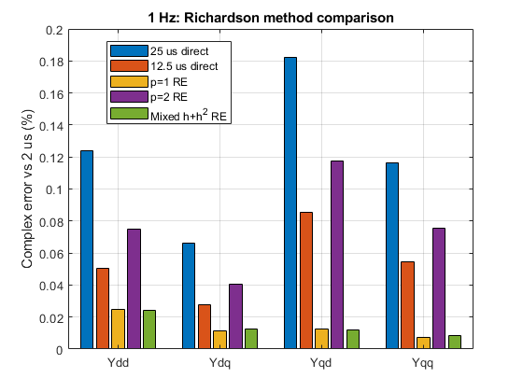 | 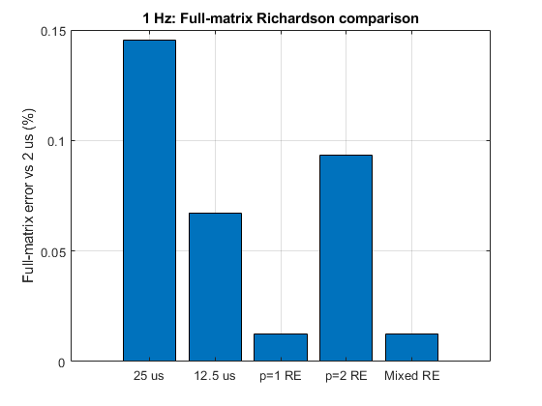
Figure 1a. Element-wise Richardson method comparison at 1 Hz. Both p=1 and mixed Richardson substantially reduce the dq-admittance error relative to the direct timestep simulations. Figure 1b. Full-matrix Richardson comparison at 1 Hz. The two results are essentially equivalent in numerical accuracy.

Observed Convergence -1 Hz
Element | 50us & 25us | 25us&12.5 us
$$Y_{dd}$$ | 1.1324 | 1.2933
$$Y_{dq}$$ | 1.1120 | 1.2553
$$Y_{qd}$$ | 1.0452 | 1.0940
$$Y_{qq}$$ | 1.0407 | 1.0953
Table 4. Observed convergence behaviour at 1 Hz.
The observed convergence is smooth and consistent across all four matrix elements.
The error-ratio angles are also small, indicating stable complex-error alignment across timestep refinement.

1 Hz Conclusion
At 1 Hz, RE1 and mixed Richardson produced full-matrix errors of 0.012588% and 0.012636%, respectively. Their difference was only 0.0000476 percentage points. Mixed was more accurate for $Y_{dd}$and $Y_{qd}$, while RE1 was more accurate for $Y_{dq}$and $Y_{qq}$. The two methods were therefore treated as practically equivalent at 1 Hz. RE1 remains the more computationally efficient choice because it requires only the 50 and 25 µs simulations.

Results at 5 Hz

Element-Wise Results
Element | 50 µs | 25 µs | 12.5 µs | RE1 | RE2 | Mixed
$$Y_{dd}$$ | 2.538099% | 1.227387% | 0.577671% | 0.084057% | 0.790327% | 0.068235%
$$Y_{dq}$$ | 1.369389% | 0.664921% | 0.313406% | 0.047409% | 0.429844% | 0.037673%
$$Y_{qd}$$ | 0.505562% | 0.249763% | 0.118745% | 0.013538% | 0.165219% | 0.014409%
$$Y_{qq}$$ | 1.744114% | 0.847395% | 0.399228% | 0.049871% | 0.548368% | 0.048764%
Table 5. Element-wise complex admittance errors at 5 Hz relative to the 2 µs reference.
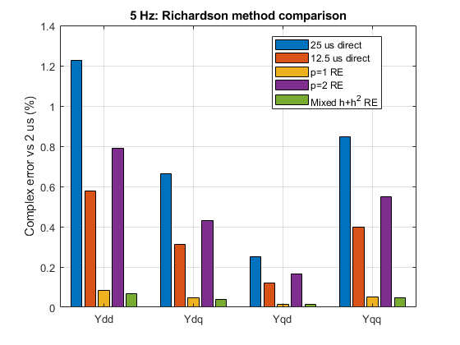 | 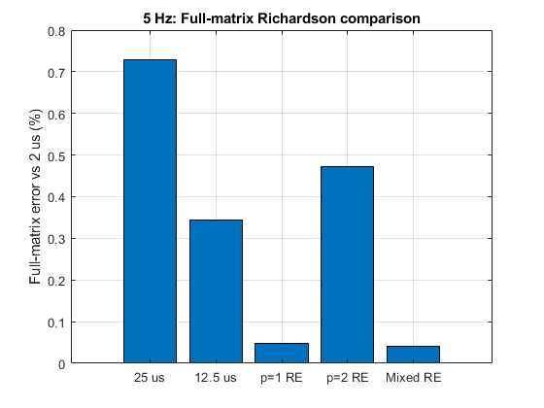
Figure 2a. Element-wise Richardson method comparison at 5 Hz. Mixed Richardson gives the lowest full-matrix error and the lowest element error for three of the four dq-admittance elements. Figure 2b. Full-matrix Richardson comparison at 5 Hz. Mixed Richardson gives the lowest error, while p=1 produces a very similar result using fewer PSCAD simulations.

Observed Convergence – 5 Hz
Element | 50us & 25us | 25us&12.5 us
$$Y_{dd}$$ | 1.0482 | 1.0873
$$Y_{dq}$$ | 1.0423 | 1.0852
$$Y_{qd}$$ | 1.0173 | 1.0727
$$Y_{qq}$$ | 1.0414 | 1.0858
Table 6. Observed convergence behaviour at 5 Hz.

5 Hz Conclusion
At 5 Hz, mixed Richardson produced the smallest full-matrix error of 0.041318%, compared with 0.048325% for RE1. Mixed therefore reduced the error by approximately 14.5% relative to RE1 and improved the direct 12.5 µs result by approximately 8.32 times. Mixed was best for three of the four admittance elements, while RE1 was marginally better for $Y_{qd}$.
Mixed Richardson therefore provides the lowest observed finite-reference discrepancy at 5 Hz. First-order Richardson remains the more efficient accelerated method because its prediction quality is nearly identical while requiring one fewer simulation.

Results at 10 Hz

Element-Wise Results
Element | 50 µs | 25 µs | 12.5 µs | RE1 | RE2 | Mixed
$$Y_{dd}$$ | 3.093659% | 1.479436% | 0.693368% | 0.137247% | 0.945651% | 0.079422%
$$Y_{dq}$$ | 2.557299% | 1.220934% | 0.571267% | 0.113167% | 0.776703% | 0.066167%
$$Y_{qd}$$ | 1.934494% | 0.915635% | 0.426481% | 0.114604% | 0.575481% | 0.049306%
$$Y_{qq}$$ | 2.059804% | 0.997398% | 0.470159% | 0.080578% | 0.646357% | 0.055114%
Table 7. Element-wise complex admittance errors at 10 Hz relative to the 2 µs reference.
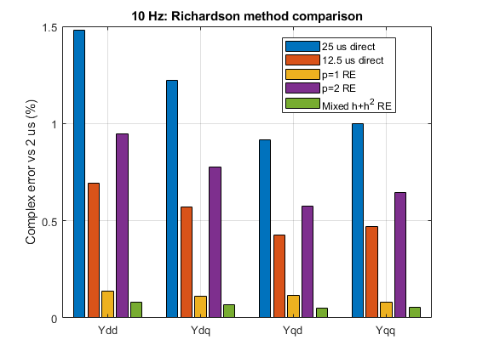 | 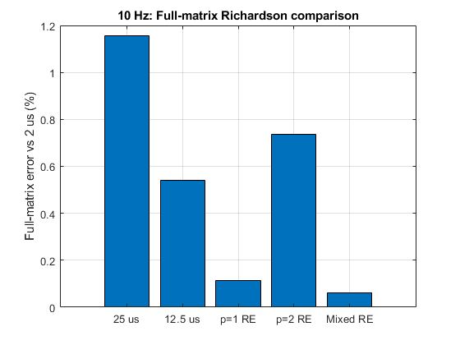
Figure 3a. Element-wise Richardson method comparison at 10 Hz. Mixed Richardson provides the smallest complex error for all four dq-admittance elements. Figure 3b. Full-matrix Richardson comparison at 10 Hz. Mixed Richardson gives the lowest error.

Observed Convergence – 10 Hz
Element | 50us & 25us | 25us&12.5 us
$$Y_{dd}$$ | 1.0643 | 1.0934
$$Y_{dq}$$ | 1.0666 | 1.0957
$$Y_{qd}$$ | 1.0791 | 1.1023
$$Y_{qq}$$ | 1.0463 | 1.0850
Table 8. Observed convergence behaviour at 10 Hz.
All four elements show similar convergence behaviour and small complex error-ratio angles.

10 Hz Conclusion
At 10 Hz, mixed Richardson was the most accurate method for all four admittance elements. Its full-matrix error was 0.062655%, compared with 0.112272% for RE1. Mixed therefore reduced the error by approximately 44.2% relative to RE1 and improved the direct 12.5 µs result by approximately 8.64 times. The increasing advantage at 10 Hz indicates that the quadratic timestep-error contribution becomes more relevant as perturbation frequency increases.
10 Hz decision: mixed Richardson is the most accurate extrapolation method for the tested timestep sequence.

Operating Point Robustness
- OP1: $P_{ref}=1.0$pu, approximately 2 MW.
- OP2: $P_{ref}=0.6$pu, approximately 1.2 MW.
- All controller, grid, perturbation and processing parameters were otherwise unchanged.
- The dq offset changed from approximately ${7.223}^{∘}$at OP1 to ${4.378}^{∘}$at OP2.
- This change is expected because active-power transfer changes the inverter-grid phase relationship.
Frequency | Operating point | RE1 | RE2 | Mixed | Interpretation
1 Hz | OP1 | 0.012636% | 0.093259% | 0.012588% | Practical tie (RE1 and mixed)
1 Hz | OP2 | 0.012414% | 0.091649% | 0.012402% | Practical tie (RE1 and mixed)
5 Hz | OP1 | 0.048325% | 0.471271% | 0.041318% | Mixed best
5 Hz | OP2 | 0.049699% | 0.482687% | 0.042106% | Mixed best
10 Hz | OP1 | 0.112272% | 0.737178% | 0.062655% | Mixed best
10 Hz | OP2 | 0.117282% | 0.756762% | 0.064853% | Mixed best
Table 9. Summary of results with operating point change

The method ranking was unchanged after reducing the active-power reference from 1.0 to 0.6 pu. At both operating points, RE1 and mixed Richardson were practically equivalent at 1 Hz, mixed was approximately 15% more accurate at 5 Hz, and mixed was approximately 44–45% more accurate at 10 Hz. The frequency-dependent benefit of the mixed formulation was therefore robust to the tested active-power variation.

Richardson Qualification Summary
Frequency | Convergence | Best accuracy | Practical decision
1 Hz | Predominantly first order | RE1 and mixed tied | Use RE1 for efficiency
5 Hz | First order with measurable curvature | Mixed | Mixed for accuracy; RE1 for fewer simulations
10 Hz | First order with stronger curvature | Mixed | Mixed provides clear accuracy benefit
Table 10. Summary of Richardson performance across perturbation frequency.

The tested sequence did not exhibit a pure second-order error model. Consequently, the pure $p=2$ formulation was not preferred at any frequency. Mixed Richardson became increasingly useful at 5 and 10 Hz because the higher-order contribution became sufficiently large for the additional cancellation to provide a measurable benefit.

Discussion – Timestep and Frequency Dependence
The direct timestep error increased with perturbation frequency. For the 50 µs direct simulation, the full-matrix error increased from 0.301% at 1 Hz to 1.502% at 5 Hz and 2.421% at 10 Hz. This shows that the identified admittance became increasingly sensitive to solver timestep as perturbation frequency increased.
Despite the increase in absolute error, the direct solutions showed systematic convergence toward the 2 µs reference. Across the four admittance elements and three frequencies, the observed orders ranged approximately from 1.02 to 1.13 over the 50–25 µs interval and from 1.07 to 1.29 over the 25–12.5 µs interval.
The convergence was therefore predominantly first order rather than purely second order. This explains why the pure $p=2$Richardson formulation was consistently less accurate than RE1 and mixed Richardson. The increase in observed order during timestep refinement also indicates that the error cannot be represented by one pure power of timestep over the complete range. Multiple timestep-dependent terms contribute to the calculated admittance.
At 1 Hz, RE1 and mixed Richardson produced practically indistinguishable full-matrix errors of 0.012588% and 0.012636%, respectively. The additional cancellation provided by the mixed formulation therefore produced no meaningful accuracy benefit at this frequency.
At 5 Hz, mixed Richardson reduced the full-matrix error to 0.041318%, compared with 0.048325% for RE1. At 10 Hz, its advantage became more substantial, reducing the error to 0.062655%, compared with 0.112272% for RE1.
These results indicate that the benefit of including both linear and quadratic timestep-error terms is frequency-dependent. RE1 is sufficient at 1 Hz, where the two extrapolations reach a similar accuracy floor. At 5 and 10 Hz, mixed Richardson provides the lowest full-matrix error, with its relative advantage increasing at the higher tested frequency.
Therefore, the appropriate Richardson formulation depends on the actual convergence behaviour, perturbation frequency and required balance between accuracy and simulation cost, rather than only on the number of formally cancelled error terms.

Limitations
The validated average-GFMI investigation was limited to:
- one validated GFMI model
- Two active power operating points
- one set of controller parameters
- three perturbation frequencies
- one d-axis perturbation amplitude of 0.01 pu
- one q-axis perturbation amplitude of 0.5°
- timestep levels of 50, 25, 12.5, and 2 µs
- an average converter representation without explicit PWM switching
- a single measurement location
- a 10 s simulation duration
- a fixed dq extraction procedure.
The conclusions therefore apply to the tested GFMI and operating condition and should not be interpreted as universal Richardson orders for all inverter models.

Failure / Rejection Conditions
Richardson extrapolation should be rejected or treated cautiously when:
- timestep simulations do not share the same logged time grid
- the operating point changes between timestep simulations
- different perturbation amplitudes are used between runs
- the response leaves the small-signal linear region
- the perturbation-voltage matrix becomes poorly conditioned
- the direct timestep sequence does not show sensible convergence
- Richardson increases the error substantially
- observed convergence differs strongly between timestep levels
- complex error-ratio angles become large
- individual admittance elements exhibit conflicting behaviour
- the analysis window contains insufficient perturbation cycles
- the dq reference frame is not defined consistently
- the results are strongly dependent on extraction settings.
These checks are required before a Richardson-refined result is accepted.

Runtime and Accuracy

PSCAD Runtime
Frequency | 50 µs | 25 µs | 12.5 µs | 2 µs
1 Hz | 5.31 s | 9.61 s | 16.51 s | 95.6 s
5 Hz | 5.68 s | 9.55 s | 16.77 s | 96.38 s
10 Hz | 5.38 s | 9.44 s | 16.63 s | 96.54 s
Table 11. Measured serial PSCAD runtime for each d+q timestep pair.
The p=1 and p=2 formulations require; T_{RE1} = T_{RE2} = T₅₀ + T₂₅
The mixed formulation requires; T_{Mixed} = T₅₀ + T₂₅+ T_{12.5.}

Richardson Runtime and Error
Frequency | Method | Required timesteps | Runtime | Error vs 2 µs | Speed-up vs 2 µs
1 Hz | p=1 RE | 50 + 25 µs | 14.92 s | 0.012636% | 6.408× faster
1 Hz | Mixed RE | 50 + 25 + 12.5 µs | 31.43 s | 0.012588% | 3.042× faster
5 Hz | p=1 RE | 50 + 25 µs | 15.23 s | 0.048325% | 6.328× faster
5 Hz | Mixed RE | 50 + 25 + 12.5 µs | 32.00 s | 0.041318% | 3.012× faster
10 Hz | p=1 RE | 50 + 25 µs | 14.82 s | 0.112272% | 6.514× faster
10 Hz | Mixed RE | 50 + 25 + 12.5 µs | 31.45 s | 0.062655% | 3.070× faster
Table 12. Accuracy and runtime of the main Richardson alternatives.
The average MATLAB post-processing time was 0.522 s. This was small compared with the PSCAD simulation runtimes and was therefore reported separately rather than included in the serial-runtime calculation.
At all three frequencies, first-order Richardson required only the 50 and 25 µs simulations and was approximately 6.3–6.5 times faster than the direct 2 µs reference. Mixed Richardson required the 50, 25 and 12.5 µs simulations but remained approximately three times faster than the direct 2 µs reference.
Therefore, both Richardson formulations provided substantial serial-runtime acceleration. First-order Richardson provided the greater speed improvement, while mixed Richardson provided better accuracy.

Accuracy–Speed Pareto Analysis
The accuracy-runtime trade-off was evaluated using Pareto plots.
The x-axis represents the total serial PSCAD runtime required for the d- and q-axis simulations. The y-axis represents the full-matrix error relative to the direct 2 µs reference.
Lower-left points therefore represent more desirable solutions because they combine lower runtime with lower error. The direct 2 µs reference has zero error by definition and is represented by its runtime rather than plotted on the logarithmic error axis.

1 Hz
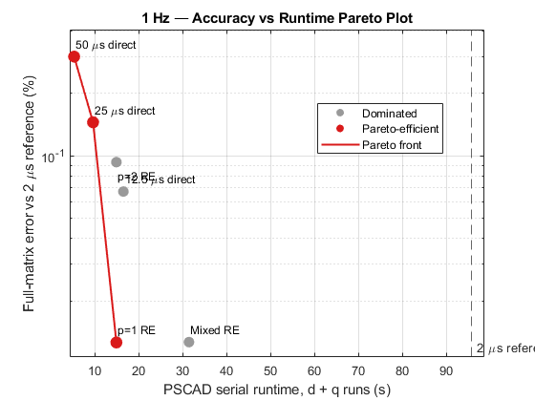
Figure 4. Accuracy-runtime Pareto plot for the validated average GFMI at 1 Hz.

Therefore, mixed Richardson is dominated by p=1 Richardson at 1 Hz.

5 Hz
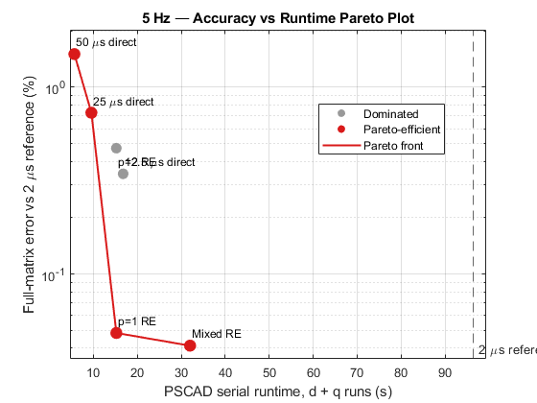
Figure 5. Accuracy-runtime Pareto plot for the validated average GFMI at 5 Hz.
At 5 Hz, mixed Richardson produced the lowest error of 0.041318%, compared with 0.048325% for first-order Richardson. This represents an approximately 14.5% reduction in error relative to first-order Richardson.
First-order Richardson required 15.23 s and was 6.328 times faster than the direct 2 µs reference. Mixed Richardson required 32.00 s and was 3.012 times faster than the reference.
Both methods are therefore useful Pareto alternatives. First-order Richardson provides the stronger runtime acceleration, while mixed Richardson provides the highest accuracy. The appropriate choice depends on whether simulation speed or minimum error has the higher priority.

10 Hz
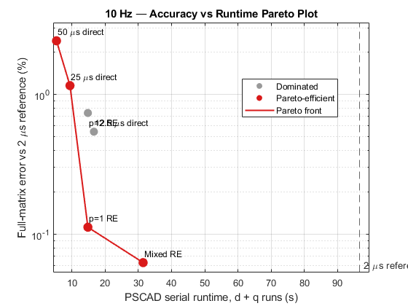
Figure 6. Accuracy-runtime Pareto plot for the validated average GFMI at 10 Hz.
At 10 Hz, mixed Richardson produced a full-matrix error of 0.062655%, compared with 0.112272% for first-order Richardson. Mixed Richardson therefore reduced the error by approximately 44.2% relative to first-order Richardson.
First-order Richardson required 14.82 s and was 6.514 times faster than the direct 2 µs reference. Mixed Richardson required 31.45 s and was still 3.070 times faster than the reference.
Mixed Richardson therefore provides both a substantial accuracy improvement and meaningful runtime acceleration at 10 Hz. First-order Richardson remains the faster alternative, but mixed Richardson provides the stronger balance when maximum admittance accuracy is required.

Comparison with Rezonance
The selected Richardson-refined admittance estimates were compared with the inverter-side admittance obtained from the validated Rezonance scan.
The manually extracted admittance was initially expressed in Siemens, while the Rezonance result was reported in per unit. The manual result was therefore converted using Y_{base} = S_{base}/V²_{base}.
Where S_{base} = 2MVA and V_{base} = 0.69kV.
This gives Y_{base} = 4.200798 S
and therefore Y_{pu} = Ys/Y_{base}
for conversion of the external result to the Rezonance base.
The manual PSCAD current direction was opposite to the Rezonance inverter-side convention. Therefore, the external admittance was also transformed using (Y_RZ = -Y_external) before comparison. This introduces the equivalent 180 deg phase reversal and places both methods in the same current-direction convention.
Frequency | Selected Richardson method | Full-matrix difference vs Rezonance
1 Hz | p=1/ Mixed Richardson | 10.74%
5 Hz | Mixed Richardson | 3.29%
10 Hz | Mixed Richardson | 2.09%
Table 13. Comparison between the selected Richardson estimate and the Rezonance inverter-side admittance.
The agreement was strongest at 5 and 10 Hz, where the full-matrix differences were only 3.29% and 2.09%. A larger difference of 10.74% remained at 1 Hz.
Additional Rezonance sensitivity tests showed that increasing the scan duration and excitation magnitude produced negligible changes in the identified admittance. Therefore, the remaining 1 Hz difference was not attributed to insufficient Rezonance scan duration or excitation amplitude.
Overall, the Rezonance comparison provides good agreement at 5 and 10 Hz and supports the external Richardson identification method, while indicating a remaining low-frequency difference at 1 Hz.

Overall Discussion
The corrected 2 µs reference results demonstrate systematic timestep convergence at 1, 5 and 10 Hz. RE1 and mixed Richardson substantially reduced the dq-admittance error at every tested frequency, whereas the pure $p=2$ formulation was consistently less accurate because the observed convergence remained predominantly first order.
At 1 Hz, RE1 and mixed Richardson reached an effective accuracy floor and were practically indistinguishable. At 5 Hz, mixed reduced the error by approximately 14.5% relative to RE1, while at 10 Hz the reduction increased to approximately 44.2%. The benefit of cancelling both linear and quadratic timestep terms therefore became more significant as perturbation frequency increased.
Repeating the analysis after reducing $P_{ref}$ from 1.0 to 0.6 pu produced the same method ranking and nearly identical errors. This demonstrates that the observed frequency-dependent Richardson behaviour is robust to the tested active-power operating-point variation.

Conclusion
Richardson extrapolation substantially reduced timestep-dependent dq-admittance error for the validated average GFMI at both tested operating points. The pure $p=2$method was not preferred because the convergence was predominantly first order over the tested timestep range.
RE1 and mixed Richardson were practically equivalent at 1 Hz. Mixed Richardson became clearly superior at 5 and 10 Hz, reducing the full-matrix error by approximately 15% and 44–45%, respectively, relative to RE1. This pattern remained consistent when the active-power reference was reduced from 1.0 to 0.6 pu.
RE1 is recommended when minimising the number of simulations is the primary objective. Mixed Richardson is recommended when maximum accuracy is required at the higher tested frequencies. Neither formulation should be selected blindly; operating-point consistency, matrix conditioning, convergence order and complex-error alignment should be checked before accepting an extrapolated result.
For the tested model and operating points:
- p=1 (h) Richardson provides the strongest overall accelerated solution
- mixed (h+h²) Richardson provides the highest accuracy
- p=2 (h²) Richardson is not the preferred formulation for the tested timestep range.
Richardson extrapolation should therefore be applied together with convergence validation and an accuracy-versus-runtime assessment rather than assuming one fixed extrapolation order for all cases.

